**PRACTICAL NO 03**

**A]Write a MongoDB query to use sum, avg, min and max expression.**

* Sum

**Query :**

db.student.aggregate([{$group: {

_id: null,

totalMarks: { $sum: "$marks" }}}])

**Output :**

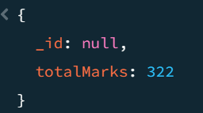

* Avg

**Query :**

db.student.aggregate([{

$group: {

_id: null,

averageMarks: { $avg: "$marks" }}}])

**Output :**

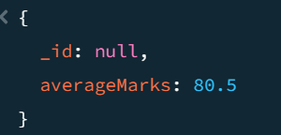

* **Min**

**Query** :

db.student.aggregate([{

$group: {

_id: null,

minMarks: { $min: "$marks" }}}])

**Output** :

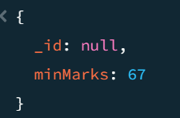

* **Max**

**Query :**

db.student.aggregate([{

$group: {

_id: null,

maxMarks: { $max: "$marks" }}}])

**Output :**

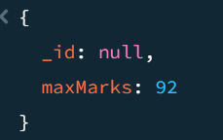

**B]Write a MongoDB query to use push and addToSet expression.**

* Push

**Query :**

db.student.aggregate([{

$group: {

_id: "$course",

studentNames: { $push: "$name" }

}}])

**Output :**

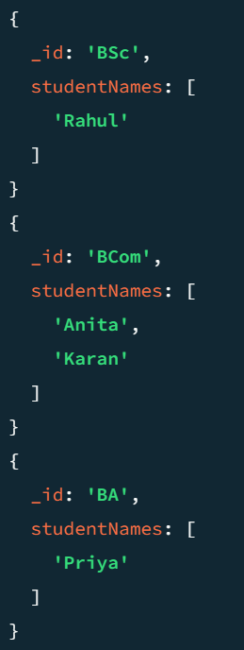

* **addToset**

**Query :**

db.student.aggregate([{

$group: {

_id: "$course",

uniqueContacts: { $addToSet: "$contacts" }

}}])

**Output :**

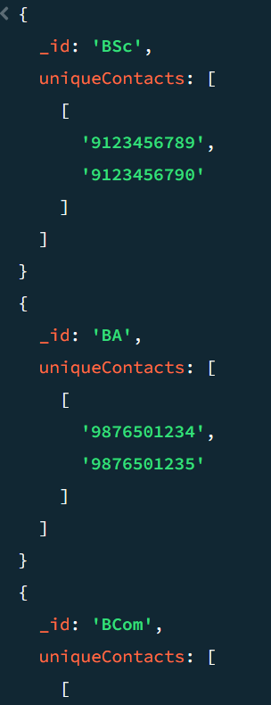

**C]Write a MongoDB query to use first and last expression.**

* **first**

**Query :**

db.student.aggregate([{ $sort: { marks: 1 } },

{

$group: {

_id: "$course",

firstStudent: { $first: "$name" },

firstMarks: { $first: "$marks" }}}])

**Output :**

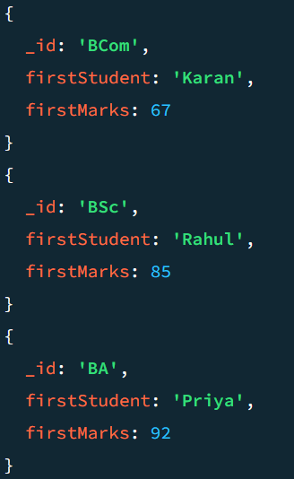

* **Last**

**Query :**

db.student.aggregate([{ $sort: { marks: 1 } },

{

$group: {

_id: "$course",

lastStudent: { $last: "$name" },

lastMarks: { $last: "$marks" }}}])

**Output:**

